井式渗氮炉技术协议

Pit Nitriding Furnace
Technology Agreement
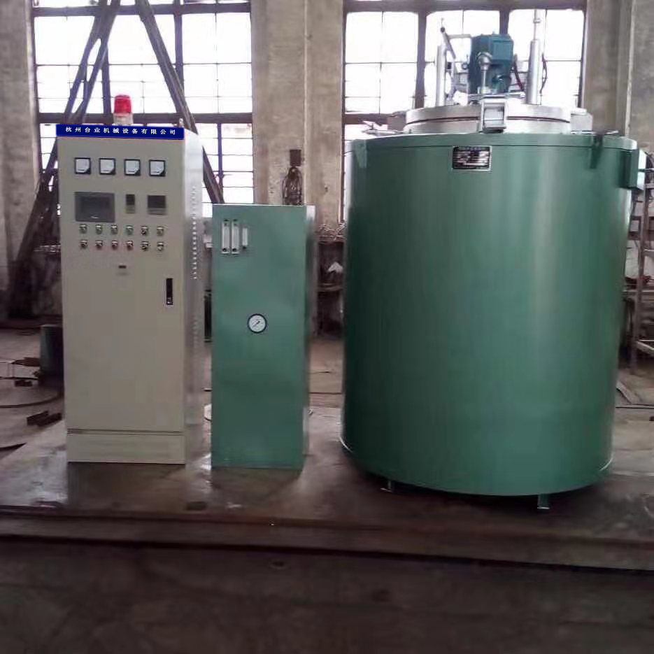

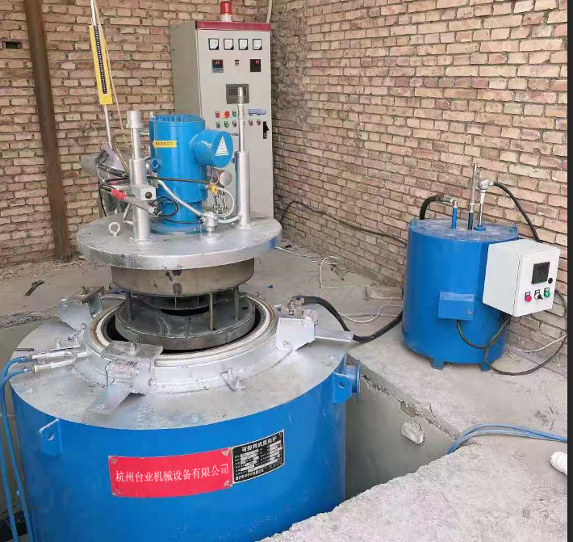
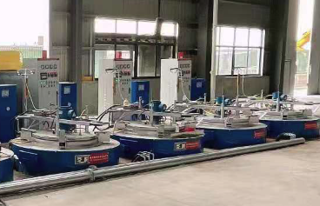

- 技术规格及说明
Part 1. Technical specifications and instructions

1.1概述
本设备适用于主要用于铝型材模具、机床主轴、机车内燃机曲轴、高精度齿轮等重要零件的在通氮状态下的气体渗氮或可控渗氮（俗称氮化），也可用于滴注有机液体软氮化，为周期性生产型热处理设备。
1.1 Overview
This equipment is suitable for gas nitriding or controllable nitriding (commonly known as nitriding) of important parts such as aluminum profile molds, machine tool spindles, locomotive internal combustion engine crankshafts, high-precision gears, etc., and can also be used for drip injection Organic liquid nitrocarburizing, it is a periodic production type heat treatment equipment.

1.2基本参数
- 装料区有效直径 φ650mm
- 装料区有效高度 1200mm
- 最大装载质量（含装料架） 不小于 1000kg
- 装料筐 需方自备
1.2 Basic parameters
The effective diameter of the loading area: φ650mm
The effective height of the loading area: 1200mm
Maximum loading mass (including loading rack): not less than 1000kg
the buyer shall prepare loading basket by himself

1.3综合数据
- 最高炉温 650 ℃
- 工作温度 ℃
- 标称功率 60KW
1.3 Comprehensive data
● Maximum furnace temperature: 650 ℃
● Working temperature: ℃
Nominal power: 60KW

1.4电能参数
- 加热电压 380V±10%
- 电动机电压 380V±10%
- 控制电压 220V±10%
- 电源频率 50Hz
- 加热功率 W±5%
- 炉丝材质
- 热风循环电机功率 2.2kW
- 快冷鼓风机 1台1.1kW
- 机械（炉盖升降）电机功率 1.1kW
- 炉内外温度显示 3块仪表
- 控温区数 2区
- 控温仪表 中外合资宇电518
- 控温方式 PID调节输出
- 控温精度 ≤±1℃
- 空炉升温时间 ≤150min
- 炉温记录 无纸记录仪
1.4 Electric energy parameters
● Heating voltage: 380V±10%
● Motor voltage: 380V±10%
● Control voltage: 220V±10%
Power frequency: 50Hz
Heating power: W±5%
Stove wire material
Hot air circulation motor power: 2.2kW
Quick cooling blower: 1 set / 1.1kW
Mechanical (furnace lid lifting) motor power: 1.1kW
The temperature inside and outside displayed: 3 meters
Number of temperature control zones: 2 zones
Temperature control instrument: Yudian 518
Temperature control method: PID regulation output
Temperature control accuracy: ≤±1℃
Empty furnace heating time: ≤150min
Furnace temperature record: Paperless recorder

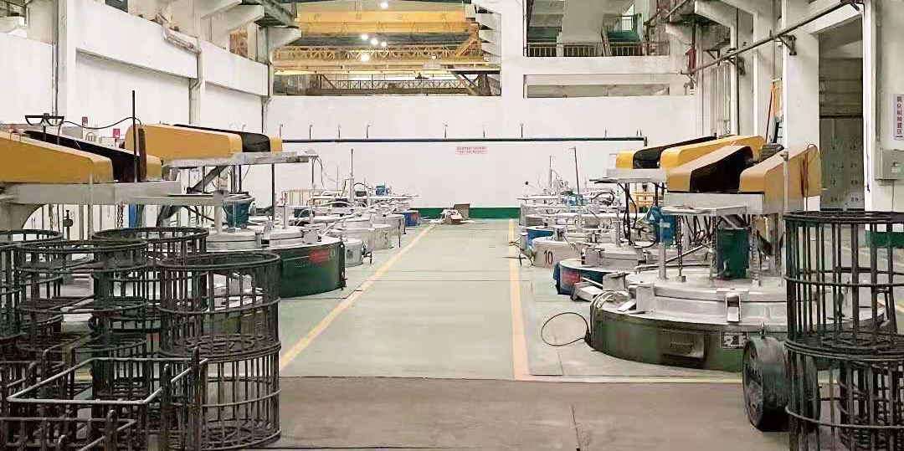

1.5设备结构及要求
本渗氮炉由炉体、马弗罐、导风筒、炉盖及炉盖提升机构、快冷供排风系统、温度控制及电气控制系统、供氮控制系统等组成。
1.5 Equipment structure and requirements
The nitriding furnace is composed of furnace body, muffle tank, air guide tube, furnace cover and furnace cover lifting mechanism, fast cooling air supply and exhaust system, temperature control and electrical control system, nitrogen supply control system, etc.

1.6炉体：炉体包括炉壳、炉衬及加热元件。
1.6.1炉壳：由型钢及优质钢板组焊而成。在炉底设有快冷风道，炉口设有排风口。
1.6.2炉衬：为全纤维耐火纤维结构，采用优质硅酸铝耐火纤维构筑，标准的锚固件及科学合理的镶装方法。纤维折叠块镶装前进行再次预压缩处理，用锚固件固定在壳体上，该结构具有低导热、低热溶优良的化学稳定性、热稳定性、抗热振性、优良的抗拉强度和抗腐蚀性。硅酸铝纤维最高耐温1000℃，锚固件的材料选用不锈钢圆钢。衬体制作完成后，表面再平贴一层纤维棉，形成一层隔热墙，增大衬体面的强度及热辐射性能，并进一步减小衬体畜热损失，达到快速升温的效果，最大限度提高炉子的热效率。
1.6.3加热元件：均匀布置在炉衬墙体的内侧，加热元件由0Cr25A15电热合金丝绕制成“之”状，分布在炉膛内，并固定。安装方式确保了加热的均匀性和使用寿命，有极高的可靠性，安装、维修、更换非常方便。
1.6 Furnace body: The furnace body includes the furnace shell, furnace lining and heating elements.
1.6.1 Furnace shell: It is assembled by welding section steel and high-quality steel plate. There is a fast cooling air duct at the bottom of the furnace, and an exhaust port is provided at the furnace mouth.
1.6.2 Furnace lining: It is a full-fiber refractory fiber structure, constructed with high-quality aluminum silicate refractory fiber, standard anchors and scientific and reasonable mounting methods. The fiber folded block is pre-compressed again before mounting and is fixed on the shell with anchors. This structure has low thermal conductivity, low thermal solubility, excellent chemical stability, thermal stability, thermal vibration resistance, excellent tensile strength and Corrosion resistance. The highest temperature resistance of aluminum silicate fiber is 1000℃, and the material of the anchor is stainless steel round steel. After the lining body is made, a layer of fiber cotton is applied on the surface to form a layer of heat insulation wall, which increases the strength and heat radiation performance of the lining surface, and further reduces the heat loss of the lining body to achieve the effect of rapid heating, maximize the thermal efficiency of the furnace.
1.6.3 Heating elements: evenly arranged on the inner side of the furnace lining wall, the heating elements are made of 0Cr25A15 electric heating alloy wire wound into a "Z" shape, distributed in the furnace, and fixed. The installation method ensures the uniformity and service life of the heating, has a high reliability, and is very convenient for installation, maintenance and replacement.

1.7马弗罐：为δ4m厚316L耐腐蚀不锈钢材料制造，在罐口设有水冷套，布置耐高温纤维编织绳及真空橡胶管密封圈，使炉盖与炉罐形成有效的密封。
1.7 Muffle tank: It is made of δ4m thick 316L corrosion-resistant stainless steel material. There is a water cooling jacket at the tank mouth, a high-temperature fiber braided rope and a vacuum rubber tube sealing ring are arranged to form an effective seal between the furnace cover and the furnace tank.

1.8导风筒（δ3mm 316L耐腐蚀含钛不锈钢材料制造）。
1.8 Air guide tube (made of δ3mm 316L corrosion-resistant titanium-containing stainless steel material).

1.9炉盖及炉盖升降机构和旋转机构
炉盖升降电机0.75KW按钮（自动升降）。炉盖采用整体式结构，炉盖升降机构由蜗轮箱、丝杆及铜螺母、限位行程开关组成。炉盖为水冷密封法兰式结构，炉罐上设置压紧装置，以保证马弗罐与炉盖之间的紧密封。炉盖上配有一台循环风机，风机电机采用密封式，确保热处理气氛处于好的工作状态，风叶为离心式多叶片结构，炉盖排气口上装有球阀和废气点燃装置。
1.9 Furnace cover and furnace cover lifting mechanism and rotating mechanism
Furnace cover lifting motor 0.75KW button (automatic lifting). The furnace cover adopts an integral structure, and the furnace cover lifting mechanism is composed of a worm gear box, a screw rod and a copper nut, and a limit travel switch. The furnace cover is a water-cooled sealing flange structure, and a pressing device is set on the furnace tank to ensure a tight seal between the muffle tank and the furnace cover. The furnace cover is equipped with a circulating fan. The motor of the fan is sealed to ensure that the heat treatment atmosphere is in a good working condition. The fan blades are of centrifugal multi-blade structure. The exhaust port of the furnace cover is equipped with a ball valve and exhaust gas igniting device.

1.10快冷送排风系统
由鼓风机以实现工艺要求的快速降温功能
1.10 Fast cooling air supply and exhaust system
The blower is used to achieve the rapid cooling function required by the process

1.11供气系统
供气系统安装在供氨柜上，供氨柜上配有干燥桶氨、分解率检测仪（水测瓶）、氨压力表和流量计组成供气调解控制。
1.11 Gas supply system
The gas supply system is installed on the ammonia supply tank. The ammonia supply tank is equipped with a drying barrel ammonia, a decomposition rate detector (water measuring bottle), an ammonia pressure gauge and a flow meter to form a gas supply adjustment control.

1.12冷却水管路
由进水口和排水口及管路组成。是用来冷却保护风机密封缸、炉盖炉罐密封圈及排气、滴注管等系统，为确保设备的正常使用，需在供水系统中安装循环水和自来水的切换装置，一旦循环水系统故障，操作人员可以立即切换到自来水循环供应冷却。
1.12 Cooling water pipeline
It is composed of water inlet, outlet and pipeline. It is used to cool and protect the fan sealing cylinder, furnace cover and furnace pot sealing ring and exhaust, dripping pipe and other systems. To ensure the normal use of the equipment, a switching device between circulating water and tap water should be installed in the water supply system. Once the circulating water system In case of failure, the operator can immediately switch to the tap water circulating supply cooling.

1.13温度控制及电气控制系统
温度控制系统由热电偶、温控仪表、固态继电器等组成。温控仪选用宇电AI518智能数显仪表，采用无纸记录仪、记录罐内温度。
电气控制系统可控制炉盖升降、热风循环电机开闭、快冷鼓风机开闭及电机过热保护等。配置电流、电压表，设置安全报警器，当加热温度超限时触发报警，响应时间为0.1s。报警时同时接通声音提示。
1.13 Temperature control and electrical control system
The temperature control system consists of thermocouples, temperature control instruments, solid state relays, etc. The temperature controller adopts Yudian AI518 intelligent digital display instrument, and adopts a paperless recorder to record the temperature in the tank.
The electrical control system can control the lifting of the furnace cover, the opening and closing of the hot air circulation motor, the opening and closing of the fast cooling blower, and the motor overheating protection. Configure current and voltmeters, set up safety alarms, and trigger an alarm when the heating temperature exceeds the limit, with a response time of 0.1s. When alarming, the sound prompt is turned on at the same time.

二.设备验收内容和依据
2.1外观质量
2.2技术参数和检验
2.3关键部位所用材质检验
2.4设备冷热调试（试炉）
2.5按双方签订技术协议
Part 2. Equipment acceptance content and basis
2.1 Appearance quality
2.2 Technical parameters and inspection
2.3 Inspection of materials used in key parts
2.4 Equipment cold and hot commissioning (test furnace)
2.5 According to the technical agreement signed by both parties

三．售后服务：
现场连接管线材料由需方提供，同时需方提供人员协助安装，设备质保期为一年，供方终身免费为需方提供技术服务，保证设备正常运转。
Part 3. After-sales service:
The on-site connecting pipeline materials are provided by the demander, and the demander provides personnel to assist in the installation. The equipment warranty period is one year, and the supplier provides free technical services for the demander for life to ensure the normal operation of the equipment.

四．成功案例：
我厂专业制造模具氮化炉，用户包括广东坚美铝业，凤铝铝业，兴发铝业，亚洲铝业，新河铝业，华昌铝业，豪美铝业，，大明铝业，英辉铝业，耀银山铝业，兴亚铝业，美源三星，国泰，恒丰，华豪，艺华，四会会丰，华伦，国耀，华南，盛泰，长兴，大洋，桃园，台山金桥，开平铝业，广西南南铝业，金苹果铝业，百色彩虹铝业，辽宁营口托田铝业，。 云南地区有玉溪红塔铝业，通海松德铝业，楚雄华湛铝业，曲靖广昌铝业，等全国几百家铝型材厂家，特别是为广东凤铝，坚美铝业，和豪美铝业制造的为10000T压机配套的大型模具氮化炉已使用多年，受到好评。
我公司最新款模具氮化炉釆用全高温棉炉内衬，取代了传统的耐火砖材料，比以前的老款环保节能省电15％以上

Part 4. success case:
Our factory has specialized in manufacturing mold nitriding furnaces. Users include Guangdong JMA Aluminum, Fenglu Aluminum, Xingfa Aluminum, Asia Aluminum, Xinhe Aluminum, Huachang Aluminum, Haomei Aluminum, Daming Aluminum, Yinghui Aluminum, Yaoyinshan Aluminum, Xingya Aluminum, Meiyuan Samsung, Guotai Aluminum, Hengfeng, Huahao, Yihua, Sihui Huifeng, Guoyao, South China, Shengtai, Changxing, Dayang, Taoyuan, Taishan Jinqiao, Kaiping Aluminum, Guangxi Nannan Aluminum, Golden Apple Aluminum, Baise Rainbow Aluminum, Yingkou Tuotian Aluminum, Yuxi Hongta Aluminum, Tonghai Songde Aluminum, Chuxiong Huazhan Aluminum, Qujing Guangchang Aluminum, etc., There are hundreds of aluminum profile manufacturers across the country are use our furnace, especially the large mold nitriding furnaces for 10000T press manufactured by Guangdong Fenglu, JMA Aluminum, and Haomei Aluminum have been used for many years and have been well received.
Our company’s latest mold nitriding furnace uses a full high temperature cotton furnace lining, which replaces the traditional refractory brick material, and saves more than 15% of energy and energy compared with the previous old model.

